

|  |
| --- |
| Support coordination services for NDIS participants practice guide February 2017 |
|  |

Contents

Part 1: Introduction 2

Background 2

Purpose 2

Scope and limitations 3

Structure 3

Part 2: NDIS participant pathway and practice guidance 4

2.1 New participant request for support (referral) practice guide 4

2.2 Assessment of a request for service 5

2.3 Service offer, service agreement and service booking 6

2.4 Support coordination service delivery 7

2.4.1 Requests for additional supports / hours (reasonable and necessary) 8

2.5 Request payment 9

2.6 Service exit and case closure 10

2.7 Performance monitoring and reporting 10

2.8 NDIS client relationship information system (CRIS) module recording 11

Appendix 13

1. New participant pathway: NDIS participant requests for DHHS support coordination services 13

2. Request for payment flowchart 14

# Part 1: Introduction

## Background

The Department of Health and Human Services’ (DHHS) is registered to provide support coordination to National Disability Insurance Scheme (NDIS) participants residing in Victoria.

The DHHS support coordination is delivered in accordance with the *National Disability Insurance Agency (NDIA) Price Guide, July 2016*, specifically the improved life choices support category (3.15)[1]. This support category includes short and long term supports that focus on strengthening the participant’s ability to coordinate their supports, and assist them to live at home and participate in their community.

**Support coordination services comprise the following elements:**

### Support connection:

* Time limited assistance to strengthen participant’s ability to connect with informal, mainstream and funded supports, and to increase capacity to maintain support relationships, resolve service delivery issues, and participate independently in NDIA processes.

### Support coordination:

* Assistance to strengthen participant’ abilities to connect to and coordinate informal, mainstream and funded supports in a complex service delivery environment. This includes resolving points of crisis, developing capacity and resilience in a participant’s network and coordinating supports from a range of sources.

### Specialist support coordination:

* Time limited support coordination, within specialist framework necessitated by high risks in a participant's situation, to address barriers and reduce complexity in environments, assisting to connect with supports, build capacity and resilience.

## Purpose

The purpose of the support coordination services for NDIS participants practice guide, December 2016 (the guide) is to assist support coordinators to implement the practice changes required to effectively respond to requests for service from NDIS participants.

The guide describes the pathway, practice and process changes for NDIS participants seeking access to DHHS support coordination. The pathway includes the steps from referral to assessment of request to offer, agreement and booking, service delivery and exit.

In addition, the guide provides practice advice for monitoring and reporting on financial and target performance outcomes and the process for claiming service delivery costs.

## Scope and limitations

The guide applies to support coordination provided by DHHS to NDIS participants only.

The process changes described in this document apply to areas which have transitioned to NDIS and are delivering support coordination to NDIS participants.

The guide will be reviewed post each area’s transition to NDIS and revise if necessary.

## Structure

The guide reflects the stages depicted in the *New Participant Pathway: NDIS Participant Requests for DHHS Support Coordination Services* (appendix 1) and provides a high level description of the tasks, processes, outcomes, supporting systems and tools required to deliver each of the stages identified.

The needs and circumstances of NDIS participants will vary and may be complex. A participant’s engagement with DHHS support coordination services may not follow a linear trajectory as illustrated in the participant pathway. For example the support coordinator may be required to intervene early or in response to a crisis. Therefore, the support coordinator must use professional judgment regarding the order or sequencing of the stages described to meet the presenting needs and circumstances of individual participants.

# Part 2: NDIS participant pathway and practice guidance

## 2.1 New participant request for support (referral) practice guide

|  |  |
| --- | --- |
| Task | Receive and acknowledge requests for support from the NDIS planner, participants and their authorised support |
| Process | * 1. **NDIA planner / local area connection (LAC) / participant:**   submit a request for support coordination services to a dedicated single entry point (support coordination email inbox)   * 1. **Manager, disability client services / team leader:**   monitor the support coordination services inbox  record requests for support and client details  provide an acknowledgement of receipt of the request for support (within one business day) |
| Outcomes | Documented request for support and client details  Timely acknowledgement of request for support |
| Supporting documents | DHHS Support Coordination – Service Statement, July 2016  CRIS NDIS module user guide  [NDIA Provider Toolkit Module 11](https://www.ndis.gov.au/providers/provider-toolkit) <https://www.ndis.gov.au/providers/provider-toolkit> |
| Required systems, tools and templates | Single entry point for requests for support (divisional inbox for support coordination services)  State-wide request for support template  NDIS participant plan |

## 2.2 Assessment of a request for service

|  |  |
| --- | --- |
| Task | Undertake preliminary review and assessment of participant request for support |
| Process | * 1. **Manager, disability client services / team leader:**   check NDIS participant status  review the participant’s NDIS support plan including hours, funding for support coordination services and payment option  discuss the requests for support with the participant’s NDIA planner or LAC and seek further information as required  consider the information provided in the request for support and determine whether it is within scope for DHHS support coordination services  consider capacity to allocate to a support coordinator  accept or rejects the request for support  provide a written feedback to the NDIA planner, LAC or participant advising of the request for support outcome  if the request for support is accepted, provides the NDIA planner, LAC or participant with the anticipated timeframe for service delivery commencement  allocate to a support coordinator  \**Note: The DHHS support coordination team provides support coordination to NDIS participants with multiple and complex needs. While participants at the support connection level are accepted, coordination of support participants are prioritised.* |
| Outcomes | Timely completion and documentation of initial assessment of the request for support |
| Supporting documents | CRIS NDIS module user guide  [NDIA Provider Toolkit Module 11](https://www.ndis.gov.au/providers/provider-toolkit) <https://www.ndis.gov.au/providers/provider-toolkit> |
| Required systems, tools and templates | NDIS support coordination initial information record  NDIA provider portal  CRIS NDIS module |

## 2.3 Service offer, service agreement and service booking

|  |  |
| --- | --- |
| **Task** | Offer DHHS support coordination services to the participant  Confirm the participant’s consent and willingness to engage service delivered by the DHHS  Complete a service agreement with the participant  Complete a service booking in the NDIA provider portal |
| **Process** | 1. Support coordinator:   open NDIS CRIS case  ensure NDIS participant plan and request for service are uploaded to CRIS  review NDIS participant plan and request for service  contact the NDIA planner or LAC to advise support coordination has been accepted by the DHHS and will be offered to the NDIS participant  confirm the participant’s consent and willingness to engage support coordination service provided by the DHHS  confirm NDIS support plan details including hours, funding and outcomes  complete a service agreement with the NDIS participant and/or their representative  develop support coordination services schedule of supports in the service agreement  request the area director or assistant director sign the service agreement   * 1. **Area director or assistant director:**   review and sign the service agreement   * 1. **Support coordinator:**   complete a service booking in accordance with the *NDIA Price Guide July 2016*  commence participant record in CRIS NDIS module  *Note: The purposes of service agreement are to identify:*  *participant’s expectation of service delivery*  *role and responsibilities of participant and support coordinator*  *agreed schedule of supports (description of support, price and payment information and how the support will be provided)*  *needs for additional hours or supports (reasonable and necessary circumstances only).* |
| **Outcomes** | Confirmation of participant consent  Completed service agreement  Completed service booking |
| **Supporting documents** | [NDIA Price Guide, July 2016](https://www.ndis.gov.au/providers/pricing-and-payment) <https://www.ndis.gov.au/providers/pricing-and-payment>  [NDIA Provider Toolkit Module 11](https://www.ndis.gov.au/providers/provider-toolkit) <https://www.ndis.gov.au/providers/provider-toolkit>  CRIS NDIS module user guide |
| **Required systems, tools and templates** | Service agreement template  CRIS NDIS module  NDIA provider portal |

## 2.4 Support coordination service delivery

|  |  |
| --- | --- |
| **Task** | Support coordination is delivered in accordance with the approved support, hours and outcomes outlined in the participant’s NDIS plan and in accordance with the signed service agreement and completed service booking |
| **Process** | *Note: support coordination services do not proceed without a service agreement and service booking.*   1. Support coordinator:   undertake worker safety risk assessment  *\*Note: Commence this process with NDIA planner, before discussing with participant / representative*  commence support coordination service delivery  deliver the supports and outcomes identified in the participant plan and specified in the service agreement (between DHHS and the participant) and service booking  record all service provision in the NDIS CRIS in accordance with the NDIS pricing arrangements and guidelines  advise the relevant NDIA planner of any significant changes in the NDIS participant’s circumstances. This may require a review of the participant’s NDIS plan and result in a change in support/hours and outcomes  advise and send copies to the relevant NDIA planner of any assessments or therapy reports produced during course of service delivery  submit reports to the NDIA on outcomes as required  prepare and support the participant for NDIS plan review  *\*Note: Plan reviews are typically conducted every 12 to 24 months, however, the review timeframe can be adjusted if a participants circumstances change.* |
| **Outcomes** | All service provision is recorded in the NDIS CRIS module in accordance with the NDIA pricing arrangements and guidelines |
| **Supporting documents** | CRIS NDIS module user guide  [NDIA Price Guide, July 2016](https://www.ndis.gov.au/providers/pricing-and-payment) <https://www.ndis.gov.au/providers/pricing-and-payment>  [NDIA Provider Toolkit Module 11](https://www.ndis.gov.au/providers/provider-toolkit) <https://www.ndis.gov.au/providers/provider-toolkit> |
| **Required systems, tools and templates** | CRIS NDIS module  NDIA provider portal |

## 2.4.1 Requests for additional supports / hours (reasonable and necessary)

|  |  |
| --- | --- |
| **Task** | In exceptional circumstances, identify participant need and request additional support or hours for support coordination |
| **Process** | 1. Support coordinator:   identify and document participant need for additional support and/or hours for support coordination services  complete a request for additional support / hours form including rationale  provide the manager / team leader with completed assessment   1. Manager, disability client services / team leader:   review and approve or reject the request additional support/hours  contact the relevant NDIA planner and request additional support / hours   1. NDIA:   approve or reject request for additional support / hours  amend and / or update the participant’s plan  update the NDIA portal   1. Support coordinator:   following NDIA approval or rejection of the request for additional support / hours, implements support coordination in accordance with the participant’s plan. |
| **Outcomes** | Completed request for additional support / hours form  NDIA approval or rejection of request for additional support / hours  NDIA portal updated  All service provision is recorded in the NDIS CRIS module in accordance with the NDIA pricing arrangements and guidelines |
| **Supporting documents** | Nil |
| **Required systems, tools and templates** | CRIS NDIS module  NDIA provider portal |

## 2.5 Request payment

|  |  |
| --- | --- |
| **Task** | Request payment for all support coordination services delivered to NDIS participants |
| **Process** | *Note: Claims from the NDIS CRIS Module should only be exported once a month, after the month in which the claims relate to.*   1. Endorsement and approval:   endorse pending NDIS support payment requests  approve endorsed NDIS support payment requests  submit the data   1. Claiming:   validate the claims data which is sourced from the CRIS system  populate NDIS bulk upload template from CRIS report  submit the NDIS bulk upload template to divisional contact  approve the claim data before all claims processed in NDIS portal  submit the claims into NDIA portal  once NDIA portal processes ‘SUCCESSFUL’ claims, then transfer the data to NDIS cash accounting tool  if there are errors with any of submitted claims, forwards errors data to relevant program areas for corrections  send recipient created tax invoice (RCTI)/remittance advice from NDIA with applicable charge codes from cash accounting tool to accounting operation  obtain RCTI and create additional invoices  monitor actuals against budgets for service delivered  update financial reports  report on cash services provided to division for review  \**Note: Process for self-managed NDIS participants’ claim will be confirmed.* |
| **Outcomes** | The division’s support coordination services achieve the prescribed service delivery target and is reimbursed for all services delivered to NDIS participants in a timely manner. |
| **Supporting documents** | Financial process for recording NDIA revenue  CRIS NDIS module user guide  [NDIA Price Guide, July 2016](https://www.ndis.gov.au/providers/pricing-and-payment) <https://www.ndis.gov.au/providers/pricing-and-payment>  [NDIA Provider Toolkit Module 11](https://www.ndis.gov.au/providers/provider-toolkit) <https://www.ndis.gov.au/providers/provider-toolkit> |
| **Required systems, tools and templates** | CRIS NDIS module  NDIA provider portal  NDIS cash accounting tool |

## 2.6 Service exit and case closure

|  |  |
| --- | --- |
| **Task** | Review and documentation of outcomes  Develop final support coordination review document  Close support coordination service provision |
| **Process** | 1. Support coordinator:   review outcomes achieved, in consultation with the participant and informal and formal supports and services involved in their life  prepare a final support coordination review document with the NDIS participant  prepare the NDIS participant, their families, carers and others for cessation of service  prepare a service cessation letter outlining outcomes achieved  record all service provision delivered in the NDIS CRIS module in accordance with the NDIA pricing arrangements and guidelines  close service provision and cease service agreement and booking |
| **Outcomes** | A final support coordination review document is provided to the NDIA planner |
| **Supporting documents** | [NDIA Price Guide, July 2016](https://www.ndis.gov.au/providers/pricing-and-payment) <https://www.ndis.gov.au/providers/pricing-and-payment>  [NDIA Provider Toolkit Module 11](https://www.ndis.gov.au/providers/provider-toolkit) <https://www.ndis.gov.au/providers/provider-toolkit>  CRIS NDIS module user guide |
| **Required systems, tools and templates** | CRIS NDIS module  NDIA provider portal  Participant feedback form |

## 2.7 Performance monitoring and reporting

|  |  |
| --- | --- |
| **Task** | Monitor and report on performance against service delivery targets and financial performance. |
| **Process** | 1. Support coordinator:   record all service provision delivered in the NDIS CRIS module in accordance with the NDIA pricing arrangements and guidelines   1. Performance and Reporting Branch (PRB):   develop monthly corporate reporting tool report  publish performance data in ePAC monthly for support coordination services |
| **Outcomes** | Support coordination services achieve the prescribed service delivery and financial targets |
| **Supporting documents** | Measurement specification  Divisional target |
| **Required systems, tools and templates** | CRIS NDIS module  Corporate reporting tool |

## 2.8 NDIS client relationship information system (CRIS) module recording

|  |  |
| --- | --- |
| **Task** | **Process** |
| **Create NDIS case** | open CRIS and search your client  navigate to 360 degree view  from ‘Go To’ look up, select ‘Add NDIS Case’  enter participant ID (available from NDIS) and use the drop down list to select the relevant participant type (i.e full participant)  select save and the ‘Case Allocation’ page will be opened  select primary assigned worker (i.e primary practitioner) and select ‘Save’ |
| **Create NDIS plan** | select the NDIS case link in the 360 degree view  select ‘NDIS Plan’ tab  enter plan start date (plan approved date)  plan end date will be automatically generated  select ‘Record Plan Allowance’  select an ‘NDIS Support Cluster’ (support coordination) and ‘Support Item’ (support connection, specialist support coordination or coordination of support)  enter service start date (date of service commencement date)  enter end date (date service will cease)  enter ‘Cluster Budget ($) as per the approved plan (i.e 5000)  select ‘Save’ |
| **Create case note and save attachment** | select the NDIS case link in the 360 degree view  select create ‘Note’ and component ‘Case’  select ‘Go’ |
| **Record support units (UoM)** | select the NDIS case link in the 360 degree view  select ‘NDIS Support’ tab  select ‘Record Support Units (UoM)’ button  enter unit of measure (hour)  enter date of support (service date)  select an appropriate support cluster (see above) and support item (see above) as per NDIS plan  leave status as ‘pending’  select ‘Save’ |
| **Search and endorse pending NDIS support** | open CRIS and select ‘NDIS search, review & approve’ icon in CRIS launch page  enter search criteria that will define the supports to be found.  it is possible to search by participant name, provider group, worker name, support cluster, support item and date range  ensure the support item status is set to ‘pending’  select ‘search’  review each item  select the checkbox for items that are ready to be endorsed  select ‘Endorse’ button  navigate to ‘Approve for Claim’ tab  select checkbox for items to be claimed  select ‘Save & Generate Claim Report’ button  divisional NDIS contact selects ‘Approve for Claim’ tab and validates the claims data and populates NDIS bulk upload template |
| **Create statement of support** | select ‘Notes & Documents’ within NDIS link  select create ‘Document’ and component ‘Case’  select ‘Go’  select hyperlink ‘Client Statement of Support’  select start & end date (document will identify all claims approved in specified time frame)  select ‘Generate’ |
| **Supporting documents** | [NDIS Records in CRIS](http://intranet.dhs.vic.gov.au/resources-and-tools/guides-and-manuals/disability-services-cris-unit-tools-and-resources) < http://intranet.dhs.vic.gov.au/resources-and-tools/guides-and-manuals/disability-services-cris-unit-tools-and-resources>t |
| **Required systems, tools and templates** | CRIS NDIS module |

# Appendix

## New participant pathway: NDIS participant requests for DHHS support coordination services

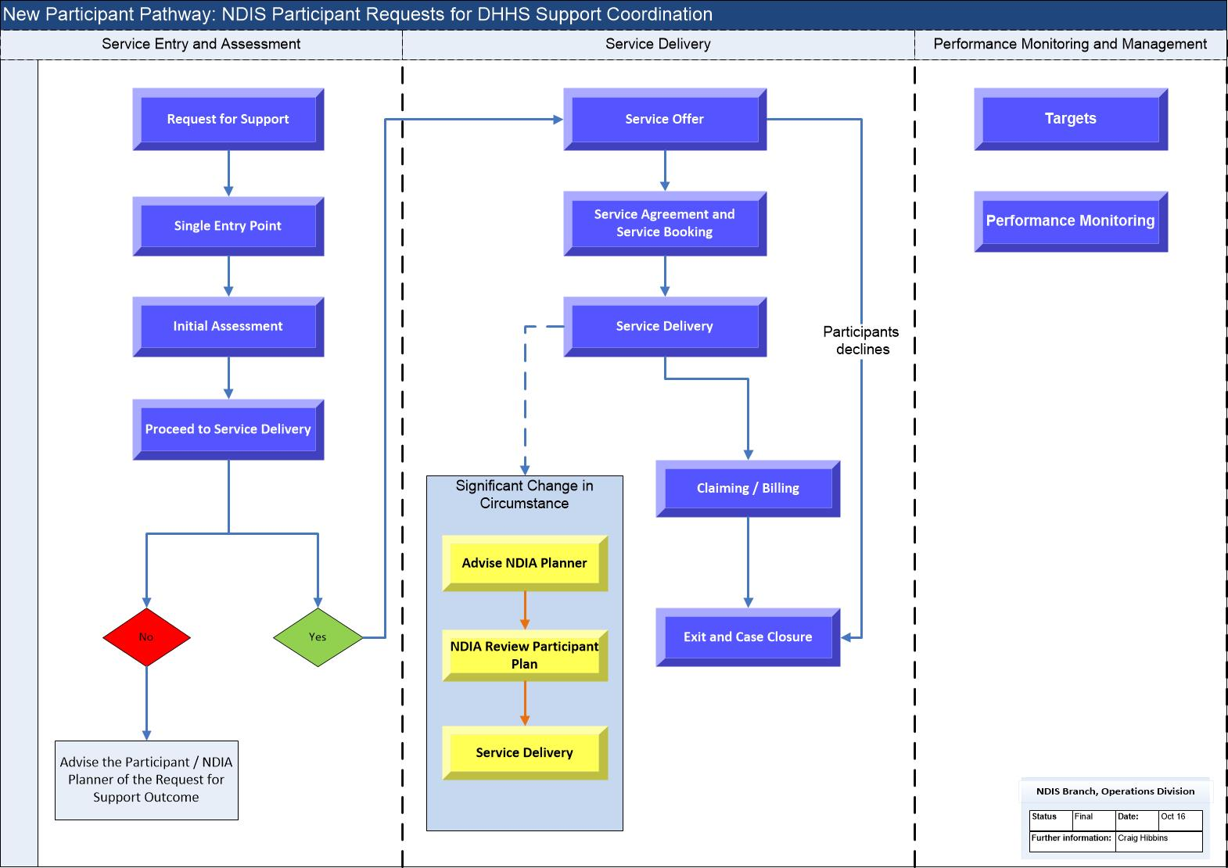

## **Request for payment flowchart**

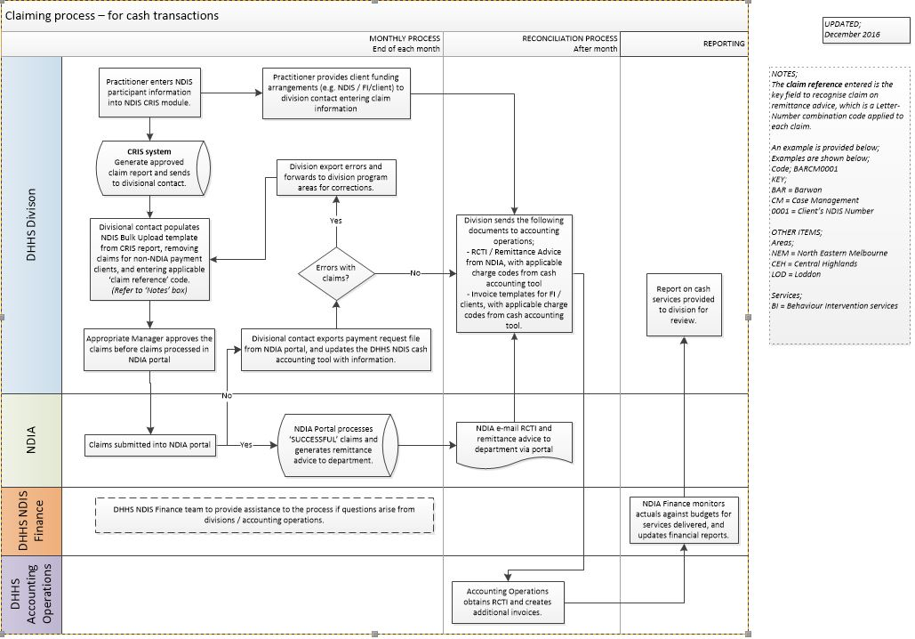

|  |
| --- |
| To receive this publication in an accessible format phone 9096 5111, using the National Relay Service 13 36 77 if required.  Authorised and published by the Victorian Government, 1 Treasury Place, Melbourne.  © State of Victoria, Department of Health and Human Services December 2016.  Available at [www.dhs.vic.gov.au/home](http://www.dhs.vic.gov.au/home) |

1. 1 [National Disability Insurance Agency Price Guide](https://www.ndis.gov.au/providers/pricing-and-payment) < https://www.ndis.gov.au/providers/pricing-and-payment >